Problem Statement: There can be multiple customers, who can place multiple orders on the site. Now a sales person can handle these orders will distribute into multiple sales persons (One order will be assign to one salesperson only). So a sales person can have multiple orders of multiple customers
- Create Database
Sol 1:
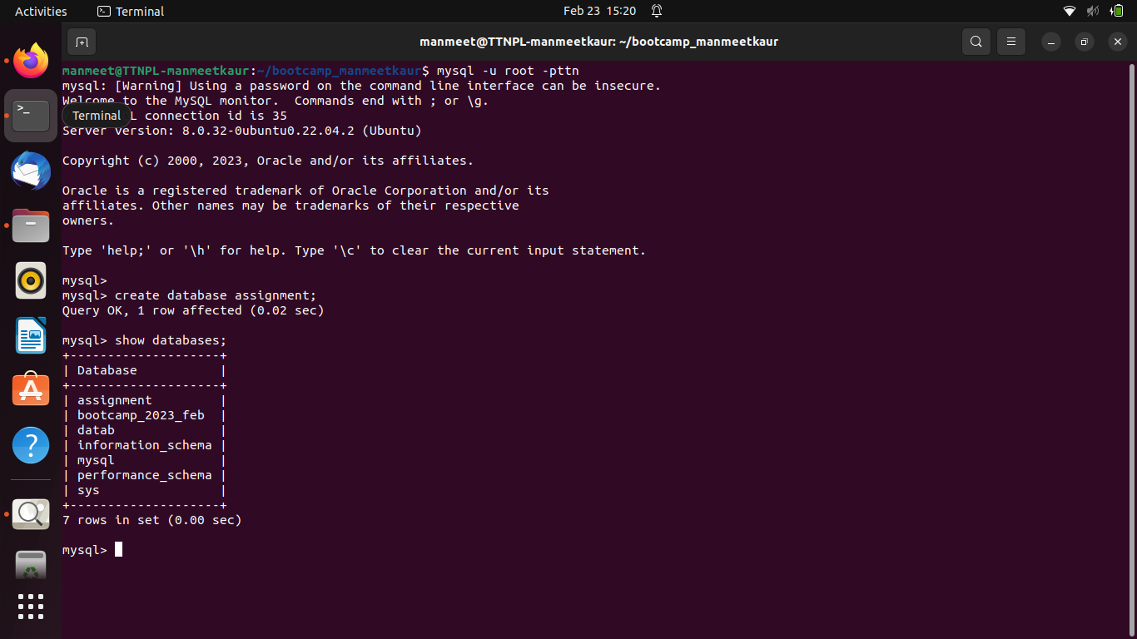
- Design Schema
Sol 2:
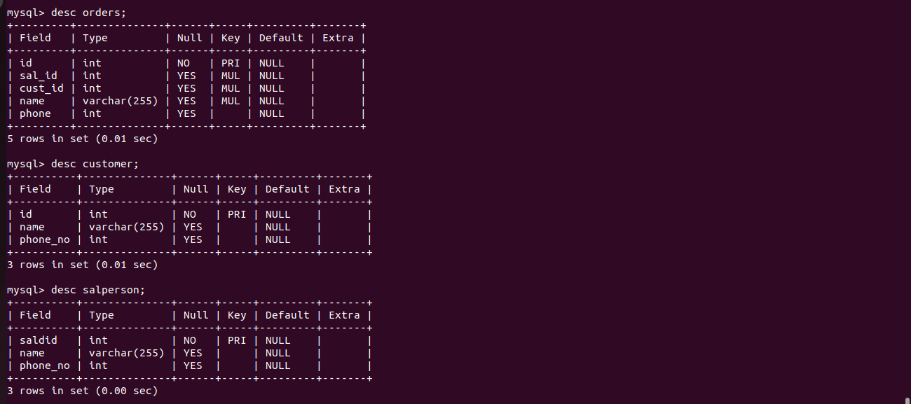
- Create tables
Sol 3: a. orders Table
b. Customer Table
c. Salesperson Table
4. Insert sample data
Sol 4:
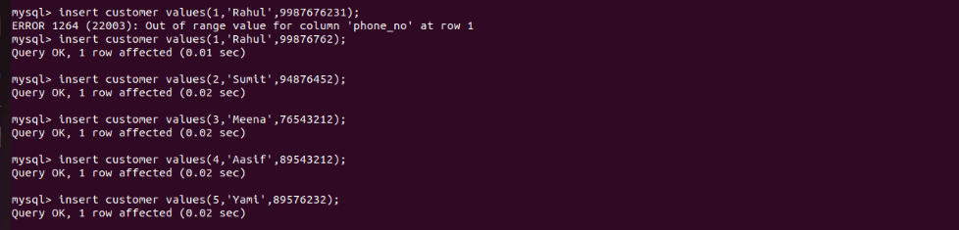
5. Find the sales person have multiple orders.
Sol 5:
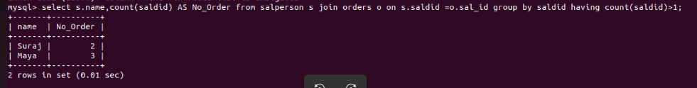
6. Find the all sales person details along with order details
Sol 6:
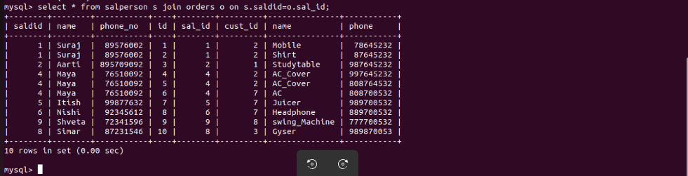
7. Create index
Sol 7:
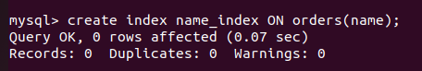

8. How to show index on a table
Sol 8:
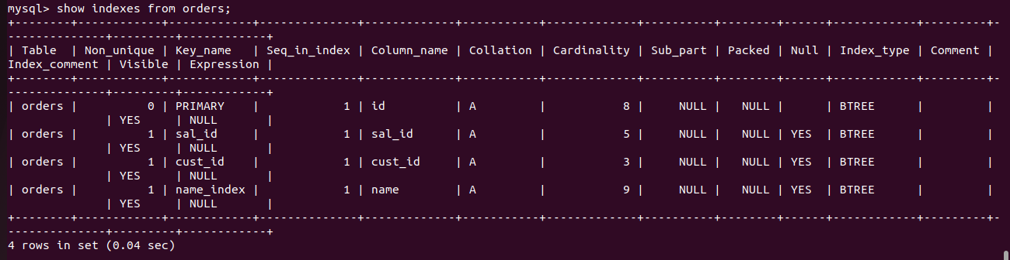
9. Find the order number, sale person name, along with the customer to whom that order belongs to
Sol 9:
